

**Green University of Bangladesh**

**Department of Computer Science and Engineering (CSE)**

**Faculty of Sciences and Engineering Semester: (Fall, Year:2022), B.Sc. in CSE (Day)**

**Course Title:digital logic design lab**

**Course Code:Dld 204 Section:213D2**

# Lab Project Name: Doorbell Ringer using OR gate

**Student Details**

|  |  |
| --- | --- |
| **Name** | **id** |
| **All-amin** | **213002019** |

**Submission Date : 7-1-2023**

**Course Teacher’s Name : Md .Mamunur Rahman**

**[For Teachers use only: Don’t Write Anything inside this box]**

**Lab Project Status**

**Marks: …………………………………**

**Signature: .....................**

**Comments: ..............................................**

**Date: ..............................**

Table of Contents

Chapter 1 Introduction 3

* 1. Introduction 3
  2. Design Goals/Objective 3

Chapter 2 Design/Development/Implementation of the Project 4

* 1. Section (Choose the name of this section as appropriate with your project) 4
  2. Section (Choose the name of this section as appropriate with your project) 4
     1. Subsection 4

Chapter 3 Performance Evaluation 5

* 1. Simulation Environment/ Simulation Procedure 5
  2. Results and Discussions 5

Chapter 4 Conclusion 6

4.1 Introduction 6

* 1. Practical Implications 6
  2. Scope of Future Work 6

References 7

# Chapter 1 Introduction

## Introduction

## We all have a doorbell at our homes. When a visitor comes to our house, he searches for the doorbell switch and then rings it to let us know his presence. If the who came to our house cannot find the doorbell or else if the person is so short that he cannot reach the doorbell, what can be done? How will it be if we use an automatic doorbell which rings as soon as a person arrives at our place? There are no more hassles. The person who comes to our house need not search for the doorbell and press it any more. If we install this automatic doorbell using object detection circuit, the circuit will automatically sense the presence of the person and it rings the doorbell.

## Design Goals/Objective

## A doorbell is a signaling device typically placed near a door to a building's entrance. When a visitor presses a button, the bell rings inside the building, alerting the occupant to the presence of the visitor.

**Chapter 2**

**Design/Development/Implementation of the Project**

.

* + 1. **Subsection**

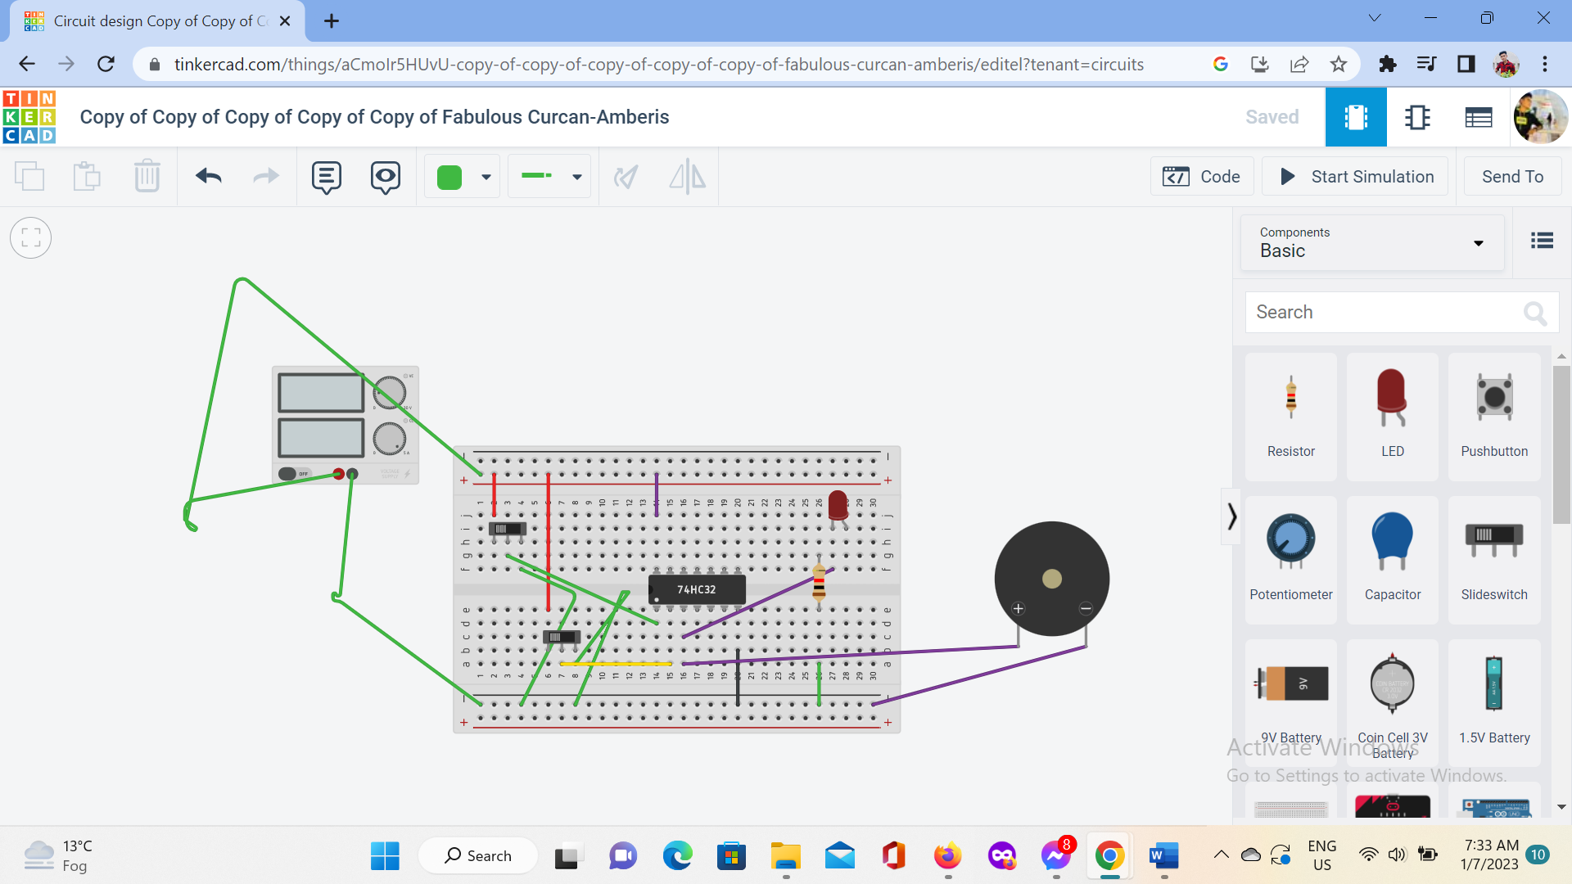

Figure 2.1: Doorbell ringer using or gate

## Circuit diagram of doorbell ringer

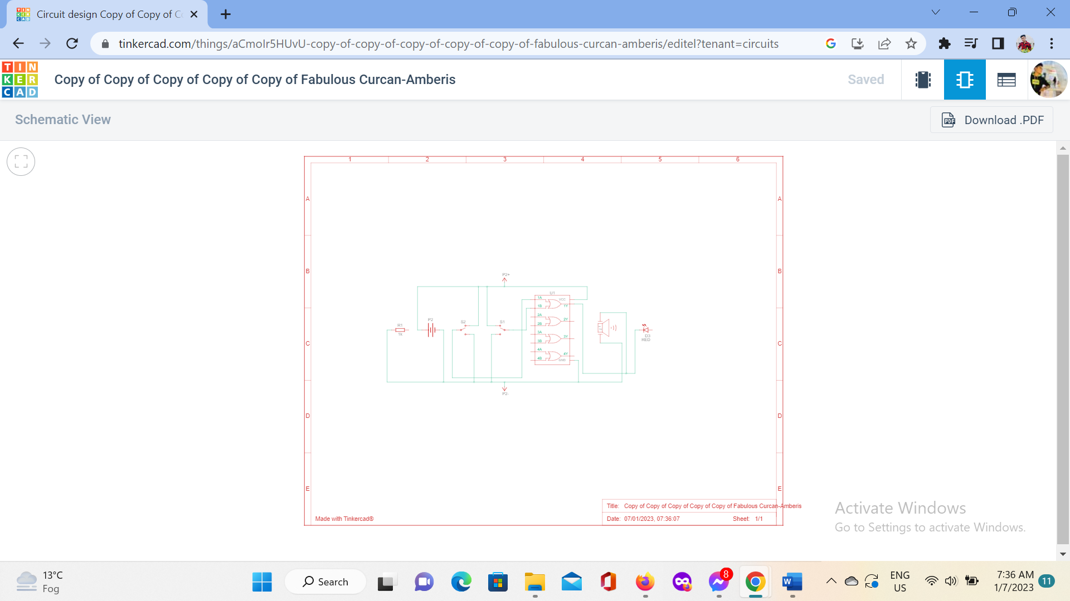

# Chapter 3 Performance Evaluation

## Simulation Environment/ Simulation Procedure

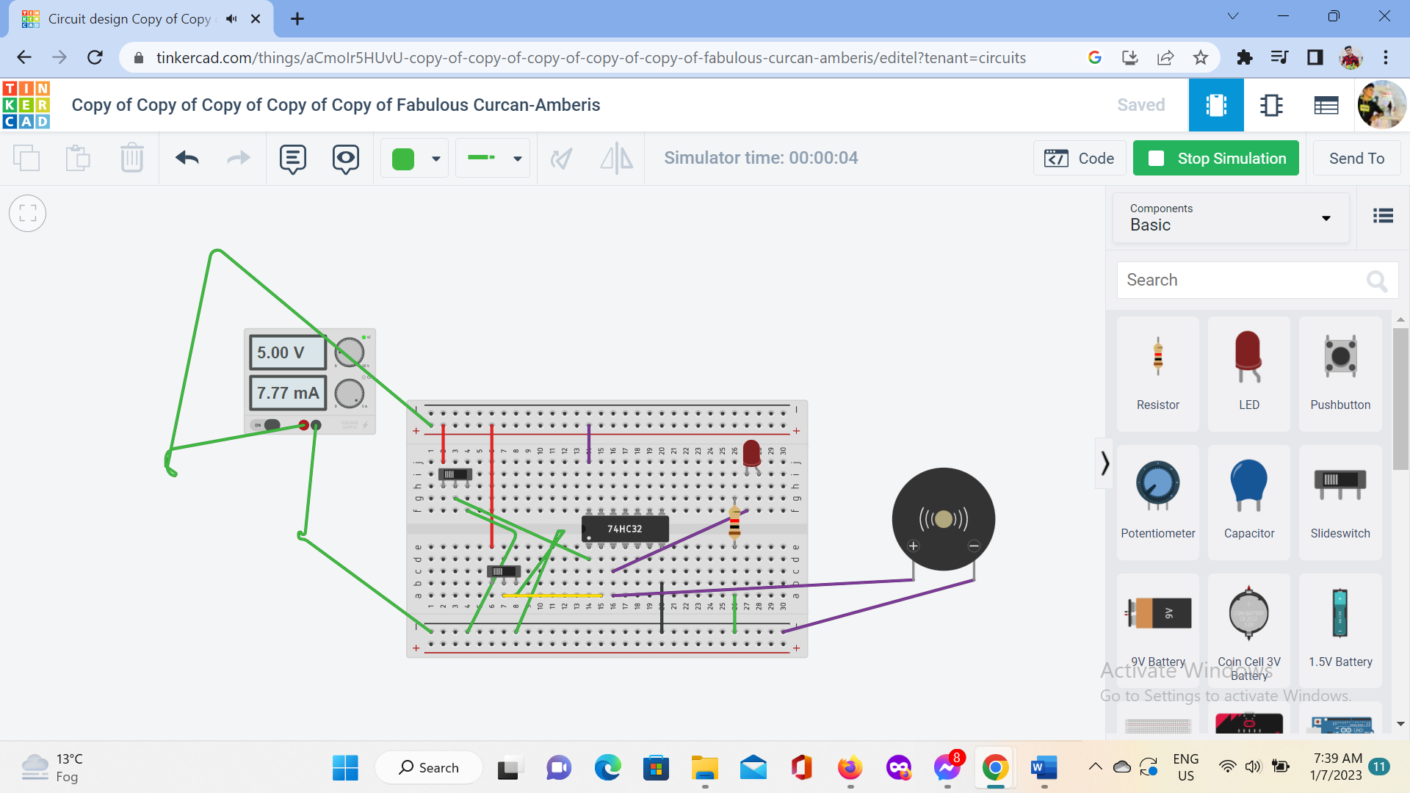

Figure 3.1: start simulation of doorbell ringer.

## Results and Discussions

When you press a doorbell button, you complete an electrical circuit that allows household electricity to flow through the doorbell's internal electromagnet. The magnetic field generated by the electromagnet is then used to power a mechanism that creates the doorbell sound. Doorbells are low-voltage devices.

# Chapter 4 Conclusion

## 4.1 Introduction

## We all have a doorbell at our homes. When a visitor comes to our house, he searches for the doorbell switch and then rings it to let us know his presence. If the who came to our house cannot find the doorbell or else if the person is so short that he cannot reach the doorbell, what can be done? How will it be if we use an automatic doorbell which rings as soon as a person arrives at our place? There are no more hassles. The person who comes to our house need not search for the doorbell and press it any more. If we install this automatic doorbell using object detection circuit, the circuit will automatically sense the presence of the person and it rings the doorbell.

## Practical Implications

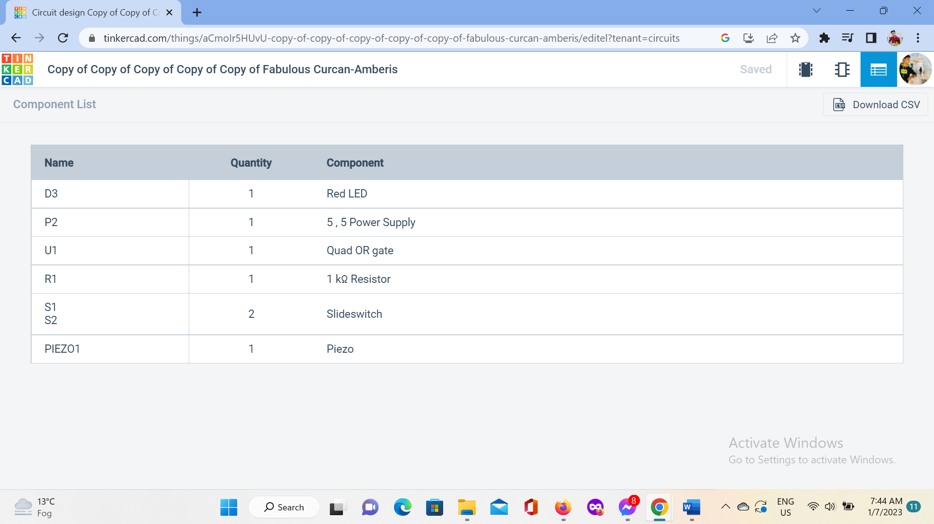

## Scope of Future Work

## If you want to avoid heavy knocking, then wireless doorbells are your best option. You can place them anywhere without worrying about wiring.

# References

# https://youtu.be/SgZte0pNWAU